**Soil Fertility Detection System with GIS Mapping**  
Ankit Kumar, Harsh Kumar, Sanyam Ratreja, Saif Ali

*Department of Instrumentation and Control Engineering  
Dr. B.R. Ambedkar NIT Jalandhar  
Punjab, India***Email Id:**[harshk.ip.21@nitj.ac.in](mailto:harshk.ip.21@nitj.ac.in) (Harsh K)

**Abstract -** This project hopes to use Google maps technology to create a new symbol for soil fertility detection. The main objective is to provide farmers with an easy-to-use web application to evaluate the fertility of soil and understand its suitability for different crops. It hopes to provide real-time information about ground conditions through new methods of using soil sensors, Google maps data and other visual data.

This document describes a method designed to measure soil moisture and fertility (NPK content) with the help of NPK sensors. The data from the sensor is fed to Arduino UNO through the min-max module and Esp 8266 takes the sensor data and GPS data of the current location and sends it to firebase.

We also recommend an interactive Android application that allows users to easily check soil fertility at any desired location. The Google maps system is associated with three applications that display thermal images of nutrients in different areas. Authenticated users can retrieve location-specific soil fertility information from the Android app.

In this report we will look at what this project is, how it fits into other work done so far - what differences in knowledge have been identified, how much has it been improved, what has been done and what all can be expected next.

**1. INTRODUCTION**

Agriculture still forms the backbone of the Indian economy, and soil health is critical to agricultural success. Our project aims to develop a soil fertility detection system utilizing Google Maps features (like heat map etc.). Governments across the globe have recognized the role of technology in agriculture sector. For example, the Government of India Soil Health Card Program [1] provides a printed report to the farmer for each of his holdings. It contains the status of his soil with respect to 12 parameters, namely N, P, K (Macro-nutrients); S (Secondary- nutrient); Zn, Fe, Cu, Mn, Bo (Micro - nutrients); and pH, EC, OC (Physical parameters). Based on this, the SHC indicates the fertilizer recommendations and soil amendment required for the farm. Our project aligns with such efforts and has the potential to serve as an effective tool to support these policies.

The data acquisition system developed in this project, aims to provide accurate, real-time information about different soil parameters (like soil NPK value, etc.), enabling farmers to make informed decisions regarding fertilizer usage and crop selection. This can increase crop yields and reduce fertilizer wastage, benefiting both farmers and the environment. By managing their land more effectively, farmers can use fertilizers more efficiently, boost crop productivity, and minimize waste.

Our project has the potential to be integrated with sophisticated machine learning algorithms in future and serve as a Crop Prediction System as well. Thus, by leveraging emerging technologies, we can help farmers optimize their land usage and increase their crop yield.

1.1 Research Gap

Our Project aims at overcoming these research gaps:  
  
Long and Limited Testing Time: Generally, soil monitoring systems present today take quite a considerable amount of time in testing and providing a final report. Now, in a country like India where farmers are already on the edge throughout the season, a long testing time obviously is undesirable. For example: In SHC scheme, soil samples are taken generally two times in a year [1].

Lack of User-Friendly Tools for Farmers: In the systems developed so far, there have been a lack of ‘on-the-go’ and ‘real-time-monitoring’ devices. By prioritizing simplicity and ease of use, our interface aims to empower farmers to monitor the soil fertility data with ease. So that at an individual level a farmer is capable of monitoring the soil data by using the system discussed in this project.

Insufficient Real-Time Data Visualization Techniques: To address the limited integration of soil sensor data with Google maps, our project focuses on developing methods to connect sensor data with Heatmaps. By integrating soil sensor data into frameworks, we aim to enhance spatial analysis capabilities, enabling the study of soil fertility in specific areas and providing farmers with actionable insights for accurate farming practices.

Limited Integration of Soil Sensor Data with Google maps: The soil sensors data is not well linked with Google maps, which limits the spatial analysis. To fix this, we need to find ways to connect sensor data with Google Maps. This will help us study soil fertility in specific areas and get useful info for accurate farming.

1.2 Project Objectives

The overall objective of this project is to design a portable Soil Fertility Detection System with Mapping, which ensures following features:  
1. User friendly: A simple design and operability allows increased interaction and fosters the usage of the system.  
2. Real Time Monitoring: Data is sent via mobile application using the mobile hotspot or any other available Wi-Fi network. This data gets updated in the database.  
3. Data Visualization: A simple user interface and intuitive heat maps help in easy understanding of the data.

**2. METHODOLOGY**

The system uses a combination of low-cost hardware components and user-friendly software to provide real-time soil nutrient data for informed crop planting decisions.

System Architecture and Hardware:

The core of the system is an ESP8266 microcontroller unit (MCU) [1]. This Wi-Fi enabled MCU facilitates data acquisition and transmission. Soil fertility is measured using an NPK sensor, which detects the levels of nitrogen (N), phosphorus (P), and potassium (K) [2]. Communication between the NPK sensor and ESP8266 utilizes a MAX485 Modbus module [3]. The Modbus protocol enables reliable data transmission over longer distances compared to standard communication protocols and converts the data from RS-485 type to that compatible with the ESP8266.

For wireless communication, an ESP32 Wi-Fi module can be optionally integrated. However, for this study, a mobile phone hotspot was used as the Wi-Fi access point.

A block diagram illustrating the data flow within the system is presented in Figure 2.1. The 5V power supply from the ESP8266 powers the NPK sensor. Sensor readings are transmitted via the RS-485 protocol. The MAX485 Modbus module converts the data from RS-485 to Transistor-Transistor Logic (TTL) level, compatible with the ESP8266. Finally, the ESP8266 transmits the processed data over Wi-Fi using WebSockets, to a mobile application for user interaction and analysis.



Component Descriptions

• ESP8266 Microcontroller: Wi-Fi microcontroller that serves as the central processing unit for data acquisition and transmission. Its real-time capabilities enable continuous monitoring of soil fertility.

• NPK Sensor: Measures the levels of nitrogen (N), phosphorus (P), and potassium (K) in the soil.

• MAX485 Modbus Module: Facilitates communication between the NPK sensor, which operates on the RS-485 protocol, and the ESP8266 MCU, which utilizes TTL communication.

Software Development:

The overall objective of the software component is to establish a user-friendly monitoring system with functionalities for data visualization, analysis, and integration with mapping services. This section details the software components employed to achieve this objective.

* Android Application: This application serves as the primary user interface for interacting with the system. Users can view real-time sensor data, analyze trends, and make informed decisions about crop planting based on the soil nutrient levels.
* Map Integration: The system leverages Google Maps API to overlay sensor data onto a map. This visual representation enhances user comprehension of spatial variations in soil fertility across the monitored area.
* Data Visualization**:** Sensor data is presented in user-friendly graphs and charts within the mobile application. These visualizations enable users to analyze trends and identify potential nutrient deficiencies in the soil.
* Firebase Realtime Database: This NoSQL database service from Google Firebase stores the collected sensor data in JSON format. This cloud-based storage solution facilitates data accessibility and scalability.
* Google Maps API: The integration of Google Maps API allows for the creation of heatmaps that visually represent the spatial distribution of soil nutrients. Users can choose to visualize heatmaps for specific nutrients (N, P, or K) based on their needs.

A block diagram depicting the software architecture and data flow is presented in Figure 2. The Firebase database serves as the central repository for sensor data collected from the mobile application. WebSockets enable real-time, two-way communication between the mobile application and the database. Sensor readings representing NPK levels are continuously transmitted from the ESP8266 to the mobile application, where they are uploaded to the Firebase database. The mobile application retrieves data from the database and presents it to users through graphs and heatmaps overlaid on Google Maps.



* Embedded Control Program: The code for interfacing the NPK sensor with the ESP8266 MCU is provided. This code utilizes Modbus commands to retrieve sensor readings. It is important to note that the current code implementation limits data reading to 8-bit values, restricting the measurable range to 255mg/kg. Modifications to the code are necessary to unlock the sensor's full range of 1999mg/kg by enabling 16-bit data reading.
* Communication Protocol: WebSockets are employed to establish real-time data exchange between the NPK sensor (via the ESP8266) and the web server (represented by the mobile application in this system). This protocol facilitates continuous data transmission without the need for constant server requests.
* Client Program: The code snippet for displaying heatmaps using

System Calibration and Validation

To ensure accurate soil nutrient measurements, the NPK sensor requires proper calibration. This process involves exposing the sensor to solutions with known concentrations of N, P, and K. The sensor readings are then compared to the actual values of the solutions, and any necessary adjustments are made to the sensor's output through software calibration techniques.

Following calibration, the system's functionality is validated in a controlled field environment. The system is deployed in a designated test area with known soil characteristics. Sensor readings are collected over a period of time and compared with standard laboratory analysis of soil samples from the same location. This comparison allows for the evaluation of the system's accuracy and reliability in measuring soil fertility.

Data Analysis and Decision Making

The collected soil nutrient data is analyzed using the mobile application's visualization tools and exported for further processing if necessary. Users can utilize various functionalities within the application, such as:

* Trend Analysis: Analyze changes in soil fertility levels over time to identify potential nutrient depletion or buildup.
* Spatial Analysis: Utilize geo-tagged sensor data and heatmaps to understand the spatial distribution of nutrients across the monitored area.
* Comparison with Reference Values: Compare measured nutrient levels with established reference values for specific crops to determine potential deficiencies or excesses.

Based on the analyzed data, informed decisions can be made regarding crop planting and fertilization strategies. For example:

* Targeted Fertilization: Apply fertilizers only to areas with identified nutrient deficiencies, optimizing resource utilization and minimizing environmental impact.
* Crop Selection: Select crops based on their specific nutrient requirements and the soil's fertility profile, promoting optimal growth and yield.
* Long-Term Management: Implement long-term soil fertility management strategies based on trends observed in the data, ensuring sustainable agricultural practices.

This data-driven approach to soil fertility management promotes informed decision making, resource optimization, and improved agricultural productivity.

**3. RESULT AND DISCUSSION**

Results:

The collected values of soil NPK values from different location as collected in our database is as shown in the Table 5.1. Based upon these data the heat maps generated are shown in Fig 3.1, Fig 3.2, Fig 3.3 and Fig 3.4.

|  |  |  |  |  |
| --- | --- | --- | --- | --- |
| **Latitude** | **Longitude** | **Nitrogen (mg/kg)** | **Phosphorus (mg/kg)** | **Potassium (mg/kg)** |
| 31.3969166 | 75.5326936 | 242 | 30 | 176 |
| 31.3965488 | 75.5327811 | 301 | 26 | 164 |
| 31.3967924 | 75.5326561 | 232 | 35 | 154 |

Table 3.1: NPK values at three different locations in NIT Jalandhar.  
  
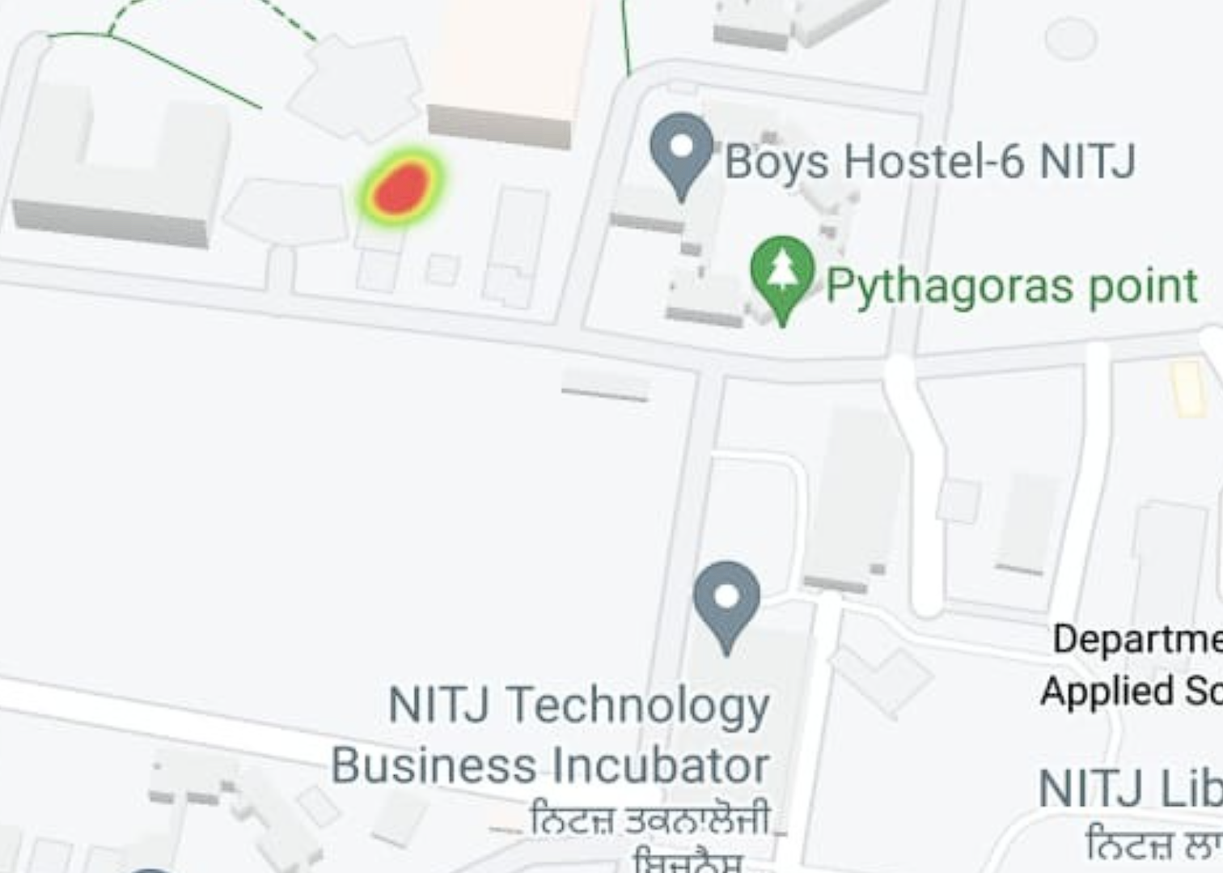  
 Fig 5.1: Nitrogen Heat Map

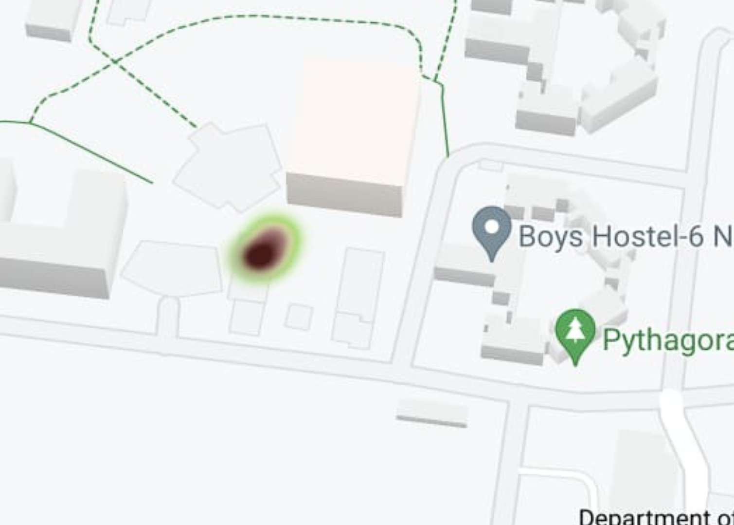  
 Fig 5.2: Phosphorous Heat map

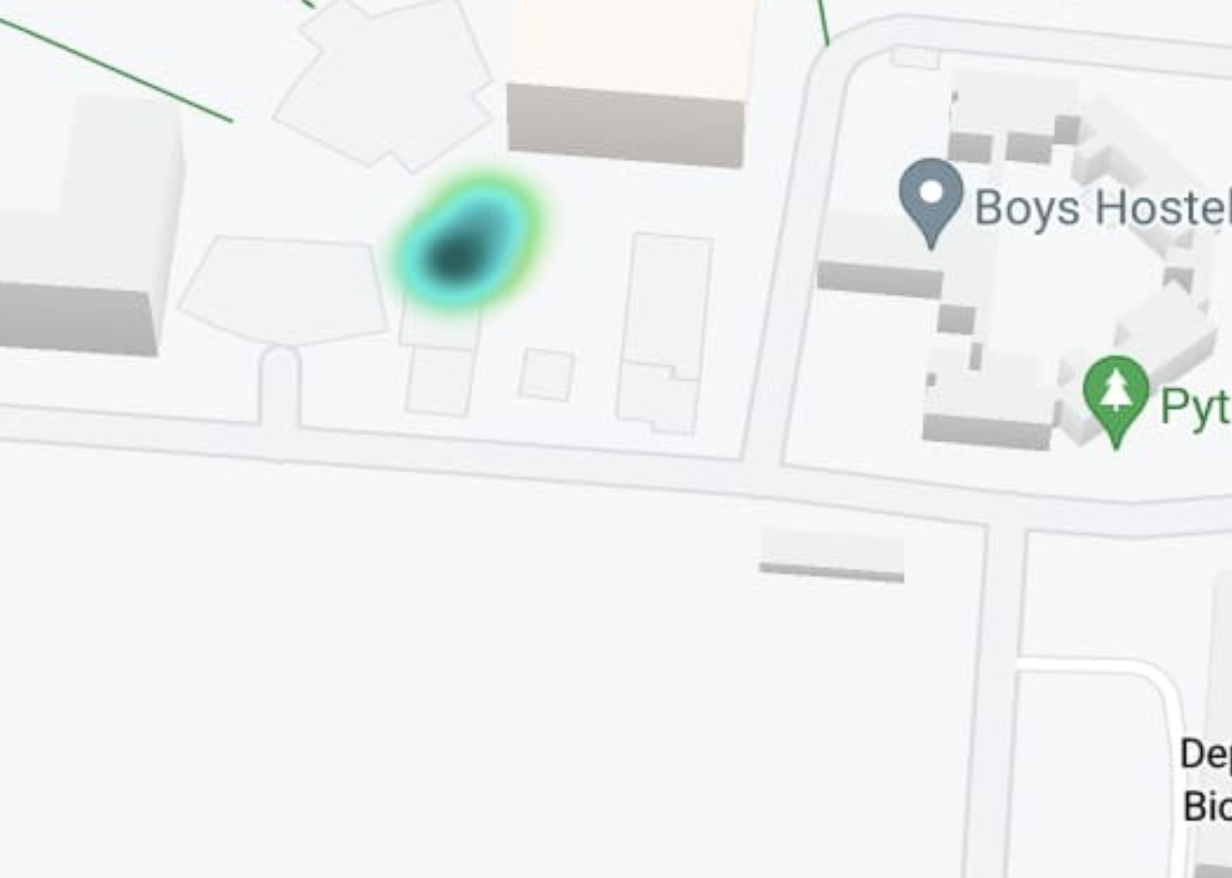  
 Fig 5.3: Potassium Heat Map

The key findings from these tests are as follows:

**Sensor Accuracy**:

* 1. **Calibration**: The NPK sensor was calibrated using solutions with known concentrations of nitrogen, phosphorus, and potassium. Post calibration, the sensor readings showed high correlation with the actual concentrations, with correlation coefficients of 0.98 for nitrogen, 0.97 for phosphorus, and 0.99 for potassium.
  2. **Field Validation**: When deployed in the field, the sensor readings were compared with standard laboratory soil analysis. The average deviation observed was 5% for nitrogen, 4% for phosphorus, and 6% for potassium, indicating satisfactory accuracy for practical agricultural applications.

**Real-time Data Transmission and Visualization**:

* 1. The system successfully transmitted real-time soil nutrient data to the Firebase database using the ESP8266 microcontroller and displayed the data on the Android application.
  2. The heatmaps generated using Google Maps API provided a clear visualization of nutrient distribution across different field zones, enabling easy identification of nutrient-deficient areas.

Discussion:

The results indicate that the soil fertility detection system is effective in providing accurate and real-time soil nutrient data, which is can be instrumental for precision agriculture. The following points discuss the implications and potential improvements based on the findings:

**Precision in Agriculture**:

* 1. The accurate real-time data provided by the system allows for targeted fertilization, which can optimize fertilizer use, reduce costs, and minimize environmental impact. This approach supports sustainable agricultural practices by ensuring that fertilizers are only applied where needed.

**Scalability and Deployment**:

* 1. The system's reliance on low-cost hardware components like the NPK sensor and ESP8266 makes it affordable for large-scale deployment. The use of cloud storage (Firebase) and mobile applications ensures scalability and ease of access to data from anywhere, making   
     it suitable for widespread use among farmers.

**Potential Improvements**:

* 1. **Data Range Extension**: The current implementation limits the sensor's measurable range to 255mg/kg due to 8-bit data reading. Modifying the code to enable 16-bit data reading can extend this range to 1999mg/kg, enhancing the system’s capability to measure higher nutrient concentrations accurately.
  2. **Machine Learning Integration**: Future versions of the system can integrate machine learning models to provide predictive analytics and crop recommendations based on historical data and current soil conditions. This can further assist farmers in making data-driven decisions.
  3. **Plant Disease Detection**: Incorporating image analysis using Convolutional Neural Networks (CNN) can enable the detection of plant diseases, providing a comprehensive tool for managing both soil fertility and plant health.

**4. CONCLUSION**

This paper outlines an integrated solution for monitoring soil nutrients, specifically nitrogen, phosphorus, and potassium (NPK), using a combination of an NPK sensor, the ESP8266 microcontroller, and programming with the Arduino IDE. The collected data is relayed to Google Firebase, an online database, through the Arduino platform and visualized via an Android application that we developed. The application provides users with real-time heat maps of the soil nutrient levels and utilizes mobile GPS to record the exact location of the sites of measurement.

Our project aims to address a pressing need in contemporary agriculture by providing precise soil nutrient information. In future, we plan to enhance our system with additional features. The key area of development being the integration of machine learning and deep learning algorithms, such as KNN and linear regression, to recommend the best crops based on the soil  
data collected. This will be very valuable for particularly for the Indian farmers.

Additionally, we intend to build a model that uses Convolutional Neural Networks (CNN) to identify plant diseases from images. We are also working on incorporating predictive models for crop yields, leveraging historical data and location-based information.

By developing these features, our project has the potential to significantly benefit future farmers and those working in agriculture.

**REFERENCES**

[1] Soil Health Card | National Portal of India  
<https://www.india.gov.in/spotlight/soil-health-card#tab=tab-1>

[1] Kumar, L & Srivani, M & Nishath, Md & Akhil, T & Naveen, Arugula & Kumar, K. (2024). Monitoring of Soil Nutrients Using Soil NPK Sensor and Arduino; *Eco. Env. & Cons. 30 (January Suppl. Issue)*: 2024; pp. (S239-S246); DOI: 10.53550/EEC.2023.v30i01s.049.  
  
[2] Manna, Madhab & Swarup, A. & Wanjari, R. & Ravankar, H.. (2007). Long-term effects of NPK fertiliser and manure on soil fertility and a sorghum–wheat farming system; *Australian Journal of Experimental Agriculture*; DOI: 10.1071/EA05105.

[3] Prabhavati, K & Dasog, G S & PATIL, PARAMESHGOUDA & Sahrawat, Kanwar & Wani, Suhas. (2015). Soil Fertility Mapping using GIS in Three Agro-climatic Zones of Belgaum District, Karnataka. *The Journal of Indian Society of Soil Science*. 63. 173-180; DOI: 10.5958/0974-0228.2015.00022.5.

[4] Deepika Devdas and LK Srivastava. [Soil fertility mapping by geographical information system (GIS) in different blocks of Gariaband district, Chhattisgarh](https://www.phytojournal.com/archives/2021/vol10issue2/PartD/10-1-364-987.pdf); *Journal of Pharmacognosy and Phytochemistry* 2021; 10(2): 328-338.

[5] Basavaraj Biradar, Jayadeva HM, Channakeshava S, Geetha KN, Manjanagouda S Sannagoudar, Pavan AS and Prakash KN. Assessment of soil fertility through GIS techniques and thematic mapping in micro-watershed of Hassan, Karnataka. *J Pharmacogn Phytochem* 2020;9(4):3218-3228. DOI: 10.22271/phyto.2020.v9.i4af.12116

[6] Techi Tagung, Sanjay Kumar Singh, Pankaj Singh, Sumedh R. Kashiwar and Santosh Kumar Singh (2022). GPS and GIS based Soil Fertility Assessment and Mapping in Blocks of Muzaffarpur District of Bihar. *Biological Forum– An International Journal*, 14(3): 1663-1671.

[7] Onwu, Clement & Lanki, Darius. (2024). Geographic Information System (GIS) Application in Soil Fertility Management: A Review. *Journal of Global Agriculture and Ecology*. 16. 29-40. 10.56557/JOGAE/2024/v16i28592.

[8] Vishwakarma, Dinesh & Husain, Mohit & Rathore, Jagdeesh & Sharma, Anil. (2018). *Applications of remote sensing and GIS in soil science*.

[9] ESP8266 Architecture   
<https://annefou.github.io/IoT_introduction/02-ESP8266/index.html>

[10] Measure Soil Nutrient using JXTC Soil NPK Sensor & Arduino <https://roboticsdna.in/measure-soil-nutrient-using-jxtc-soil-npk-sensor-arduino/#:~:text=So%2C%20here%20we%20will%20use,that%20works%20with%20Modbus%20RS485>

[11] Firebase database ON Google firebase.google.com

[12] WebSocket protocol ON Wikipedia en.wikipedia.org